Title | Interactive Bar Chart with Plotly
Problem Statement | Create an interactive bar chart showing the population of different cities.
Objectives | • To understand the creation of interactive data visualizations using Plotly.  • To organize city population data in a Pandas DataFrame.  • To create an interactive bar chart for comparing population across different cities.  • To sort and analyze population data to identify the highest, lowest, and average values.  • To save the interactive chart as an HTML file and the dataset as a CSV file.
Dataset  URL Link /  File | City Population (Lakhs)  Mumbai 204  Delhi 167  Bengaluru 136  Hyderabad 108  Chennai 115  Kolkata 149  Dataset source: Manually defined in the Jupyter Notebook for this exercise; no external dataset URL is required.
Functions  Details | Sl. No. | Function | Package | Description of function
 | 1 | pd.DataFrame() | pandas | Creates a structured DataFrame from the city and population data.
 | 2 | px.bar() | plotly.express | Creates an interactive bar chart from the DataFrame.
 | 3 | update_traces() | plotly | Updates trace properties such as the position of value labels on the bars.
 | 4 | update_layout() | plotly | Updates chart layout properties including axis titles.
 | 5 | show() | plotly | Displays the interactive Plotly figure in the Jupyter Notebook.
 | 6 | sort_values() | pandas | Sorts the DataFrame based on population values in ascending or descending order.
 | 7 | idxmax() | pandas | Returns the index of the row containing the maximum population value.
 | 8 | idxmin() | pandas | Returns the index of the row containing the minimum population value.
 | 9 | mean() | pandas | Calculates the average population of all cities.
 | 10 | round() | Python | Rounds the calculated average population to the required decimal places.
 | 11 | write_html() | plotly | Saves the interactive Plotly chart as an HTML file.
 | 12 | to_csv() | pandas | Saves the DataFrame as a CSV file without the index column.
Steps/  Process/  Procedure/  Algorithm/  Flowchart/  Model | 1. Import the Pandas library and Plotly Express for data handling and interactive visualization.  2. Create a dictionary containing the names of six Indian cities and their population values in lakhs.  3. Convert the dictionary into a Pandas DataFrame and display the dataset.  4. Check the dataset shape and print the city and population lists to verify the input data.  5. Create an interactive bar chart using Plotly Express with City on the X-axis and Population (Lakhs) on the Y-axis.  6. Display population values above the bars and provide appropriate chart and axis titles.  7. Sort the DataFrame in descending order of population using sort_values().  8. Create and display a second interactive bar chart using the sorted population data.  9. Use idxmax() and idxmin() to identify the cities with the highest and lowest populations.  10. Calculate the average population using mean() and round the result to two decimal places.  11. Display the final population analysis summary in the notebook.  12. Save the interactive Plotly chart as city_population_chart.html and save the dataset as city_population.csv.  Flow: START → Import Libraries → Create Dataset → DataFrame → Verify Data → Interactive Bar Chart → Sort Data → Sorted Chart → Population Statistics → Save HTML/CSV → STOP
Program | import pandas as pd  import plotly.express as px  data = {  "City": [  "Mumbai",  "Delhi",  "Bengaluru",  "Hyderabad",  "Chennai",  "Kolkata"  ],  "Population (Lakhs)": [  204,  167,  136,  108,  115,  149  ]  }  df = pd.DataFrame(data)  df  print("Dataset Shape:", df.shape)  print("\nCities:")  print(df["City"].tolist())  print("\nPopulation:")  print(df["Population (Lakhs)"].tolist())  fig = px.bar(  df,  x="City",  y="Population (Lakhs)",  title="Population of Major Indian Cities",  text="Population (Lakhs)"  )  fig.update_traces(textposition="outside")  fig.update_layout(  xaxis_title="City",  yaxis_title="Population (Lakhs)"  )  fig.show()  sorted_df = df.sort_values(  by="Population (Lakhs)",  ascending=False  )  sorted_df  fig = px.bar(  sorted_df,  x="City",  y="Population (Lakhs)",  title="City-wise Population Analysis",  text="Population (Lakhs)"  )  fig.update_traces(textposition="outside")  fig.update_layout(  xaxis_title="City",  yaxis_title="Population (Lakhs)"  )  fig.show()  highest = df.loc[  df["Population (Lakhs)"].idxmax()  ]  print("City with Highest Population:")  print(highest)  lowest = df.loc[  df["Population (Lakhs)"].idxmin()  ]  print(  "Lowest Population:",  lowest["City"],  "-",  lowest["Population (Lakhs)"],  "Lakhs"  )  average_population = df["Population (Lakhs)"].mean()  print(  "Average Population:",  round(average_population, 2),  "Lakhs"  )  print("CITY POPULATION ANALYSIS")  print("-" * 35)  print("Total Cities:", len(df))  print(  "Highest Population:",  df.loc[df["Population (Lakhs)"].idxmax(), "City"]  )  print(  "Lowest Population:",  df.loc[df["Population (Lakhs)"].idxmin(), "City"]  )  print(  "Average Population:",  round(df["Population (Lakhs)"].mean(), 2),  "Lakhs"  )  fig.write_html(  "city_population_chart.html"  )  print("Interactive chart saved successfully.")  df.to_csv(  "city_population.csv",  index=False  )  print("Dataset saved successfully.")
Output Snapshots  With  Explanation/  Observations | The following output snapshots are taken from the completed Jupyter Notebook. Each image is inserted at full content width so that the dataset, charts, code cells, and output values remain readable and are not cut off.  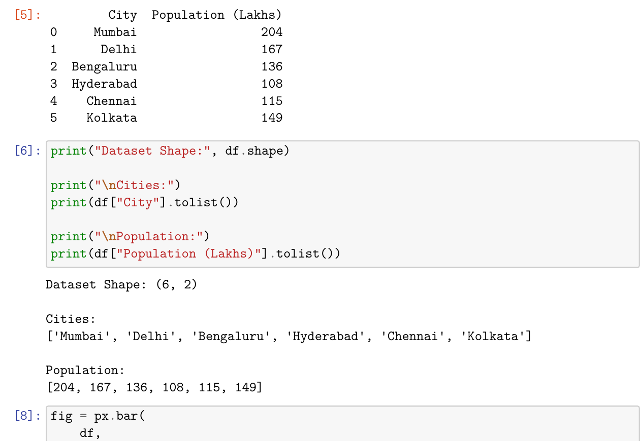  Fig. 1.1: Population Dataset and Dataset Structure  Explanation/Observation: The DataFrame verifies 6 cities and their corresponding population values.  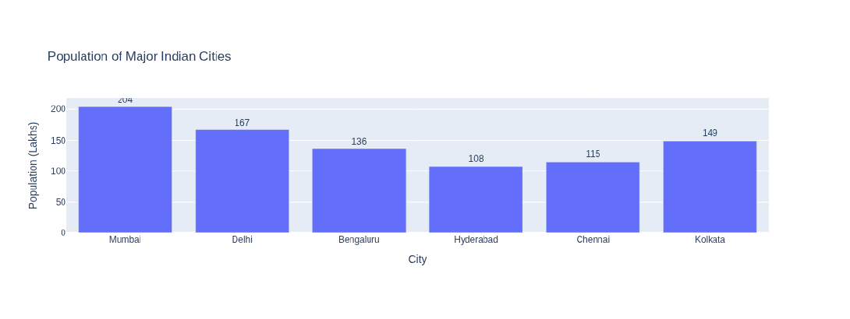  Fig. 1.2: Interactive Bar Chart of Major Indian Cities  Explanation/Observation: Plotly Express generates an interactive bar chart for the original city order. The population values are displayed above the bars, with Mumbai showing the highest value of 204 lakhs in the given dataset.  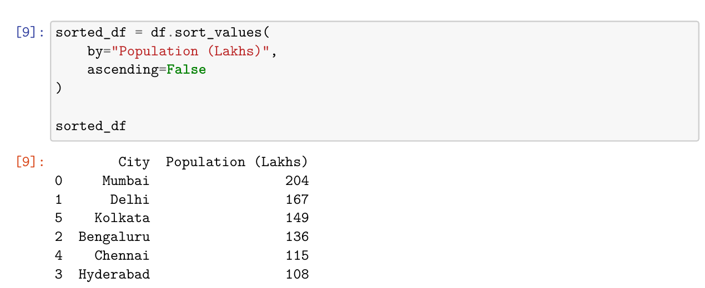  Fig. 1.3: Population Data Sorted in Descending Order  Explanation/Observation: The DataFrame is sorted using sort_values() in descending order of population. The resulting order is Mumbai, Delhi, Kolkata, Bengaluru, Chennai, and Hyderabad.  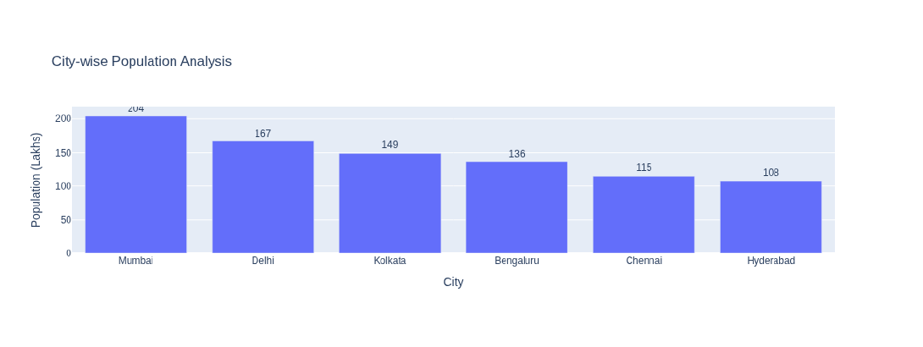  Fig. 1.4: City-wise Population Analysis after Sorting  Explanation/Observation: The sorted bar chart displays the cities from highest to lowest population, making comparison and ranking easier.  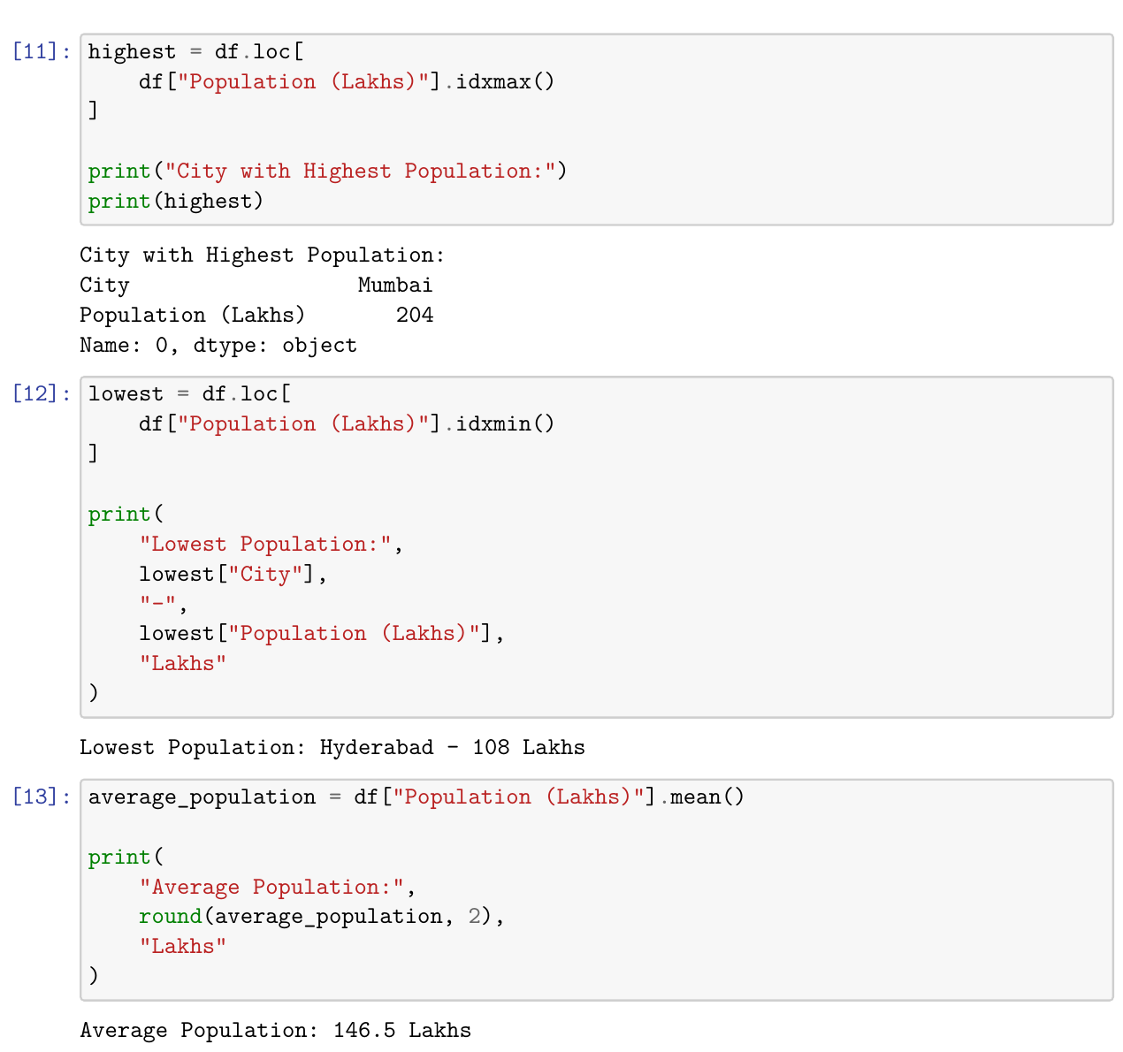  Fig. 1.5: Highest, Lowest, and Average Population Analysis  Explanation/Observation: The program identifies Mumbai as the city with the highest population (204 lakhs), Hyderabad as the city with the lowest population (108 lakhs), and calculates the average population as 146.5 lakhs.  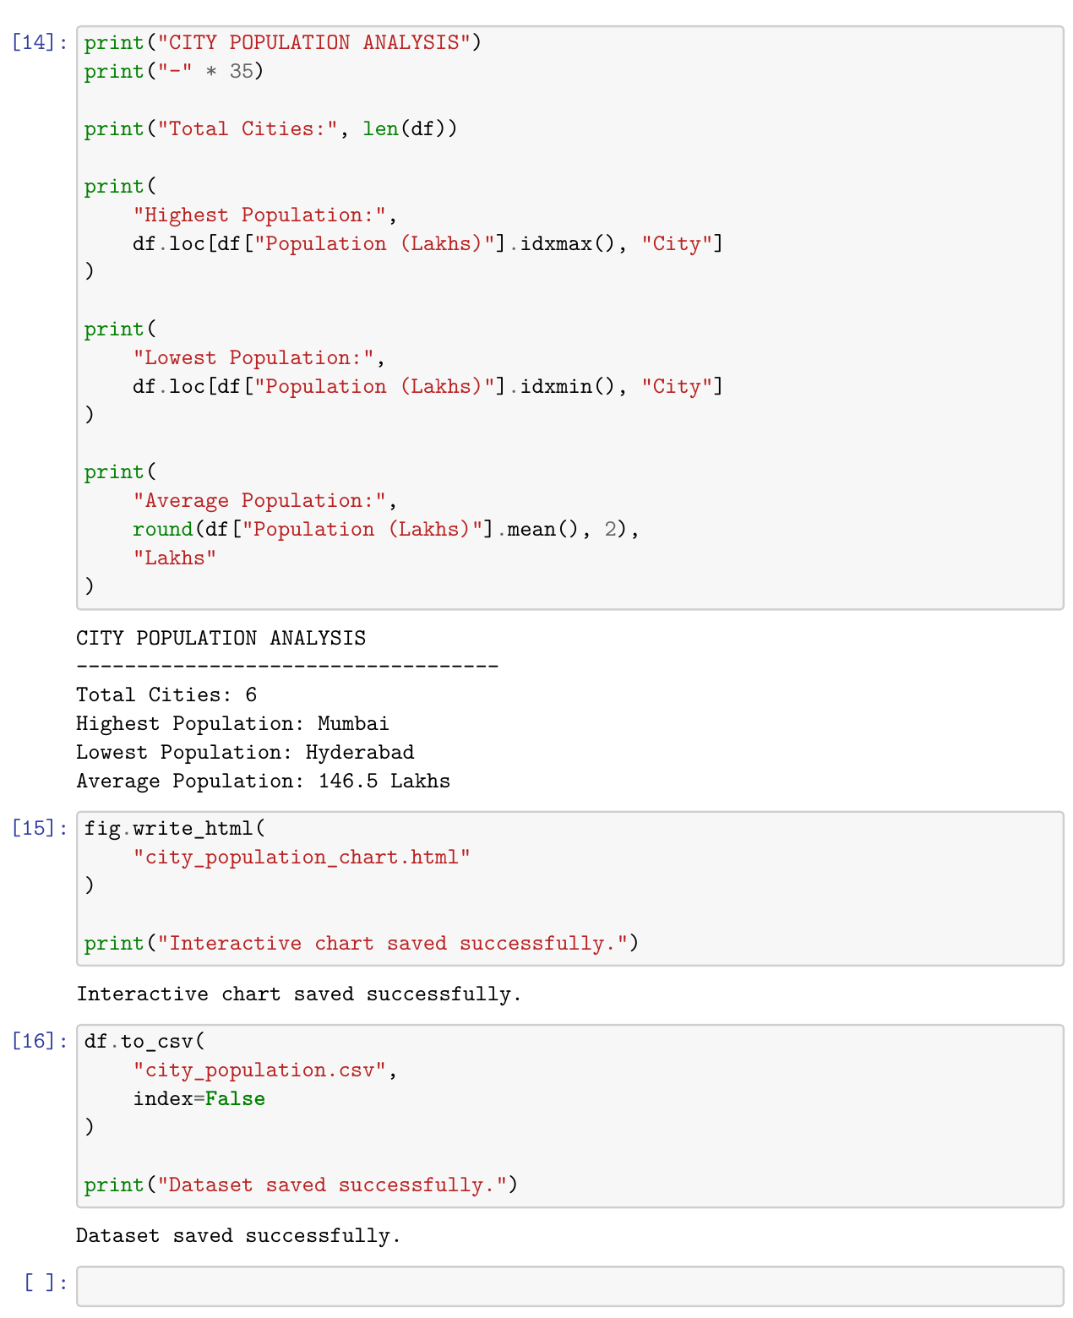  Fig. 1.6: Final Analysis Summary and File Saving Output  Explanation/Observation: The final summary confirms 6 cities were analyzed, with Mumbai highest and Hyderabad lowest. The interactive chart and CSV dataset are saved successfully.
Conclusions | The experiment was successfully completed using Pandas and Plotly. The population data was organized in a DataFrame, visualized with interactive bar charts, and sorted for comparison. Mumbai had the highest population, Hyderabad the lowest, and the average population was 146.5 lakhs. The interactive chart was saved as HTML and the dataset as CSV.
References | 1. Michael Freeman and Joel Ross, Programming Skills for Data Science, Addison-Wesley, 2018.  2. Python Program (GitHub link):  3. Class lecture link: Open Lecture File

